CONGRATULATIONS!

CONGRATULATIONS!
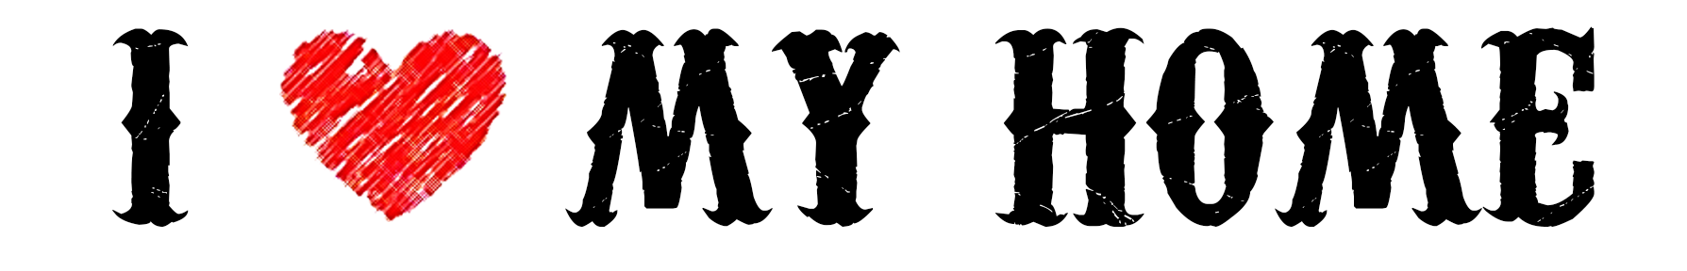
It was an honor to be a part of your home search! I hope the transition goes smoothly and your home is everything we were looking for and more. Feel free to call me anytime with questions or if I can be of any help to you or your friends and family! Thank you!
It was an honor to be a part of your home search! I hope the transition goes smoothly and your home is everything we were looking for and more. Feel free to call me anytime with questions or if I can be of any help to you or your friends and family! Thank you!

